The image shows a WandB (Weights & Biases) training dashboard, used to monitor model performance during fine-tuning or training. Here’s a breakdown of the diagrams visible:
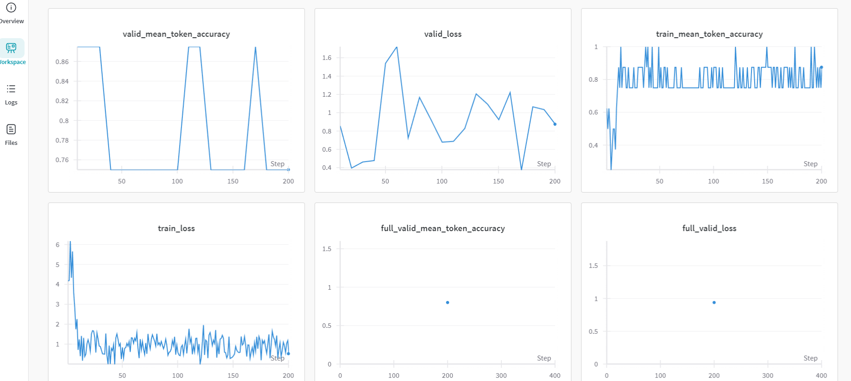

📊 Diagrams and Their Meanings:
- Top Left: valid_mean_token_accuracy
  - Accuracy on the validation dataset (per token).
  - Indicates how well the model generalizes.
  - Fluctuations suggest instability or small validation size.
- Top Middle: valid_loss
  - Loss on the validation set.
  - Should generally decrease over time. Spikes may indicate overfitting or data issues.
- Top Right: train_mean_token_accuracy
  - Accuracy on the training dataset (per token).
  - High but volatile values suggest the model fits training data but may overfit.
- Bottom Left: train_loss
  - Training loss.
  - Ideally decreases smoothly; some noise is typical.
- Bottom Middle: full_valid_mean_token_accuracy
  - Final mean token accuracy on the full validation set at end-of-run.
  - May only record at the last step or checkpoint.
- Bottom Right: full_valid_loss
  - Final validation loss value.
  - Recorded after all validation batches.

✅ Purpose of These Charts in WandB:
They help you:
- Detect overfitting (train accuracy ↑, valid accuracy ↓)
- Confirm learning progression (loss ↓ over time)
- Compare different runs visually
- Diagnose model/data issues early

Let me know if you'd like to:
- Enable early stopping based on valid_loss
- Smooth noisy curves in WandB
- Export these metrics for reporting or comparison

